Exercise 2: E-commerce Platform Search Function
using System;
class Product
{
public int Id;
public string Name;
public Product(int id, string name)
{
Id = id;
Name = name;
}
}
class Program
{
static int LinearSearch(Product[] products, string key)
{
for (int i = 0; i < products.Length; i++)
{
if (products[i].Name.ToLower() == key.ToLower())
{
return i;
}
}
return -1;
}
static void Main(string[] args)
{
Product[] products =
{
new Product(101,"Laptop"),
new Product(102,"Mouse"),
new Product(103,"Keyboard"),
new Product(104,"Monitor"),
new Product(105,"Printer")
};
Console.Write("Enter Product Name: ");
string search = Console.ReadLine();
int index = LinearSearch(products, search);
if(index!=-1)
{
Console.WriteLine("Product Found");
Console.WriteLine("ID : " + products[index].Id);
Console.WriteLine("Name : " + products[index].Name);
}
else
{
Console.WriteLine("Product Not Found");
}
}
}
OUTPUT:
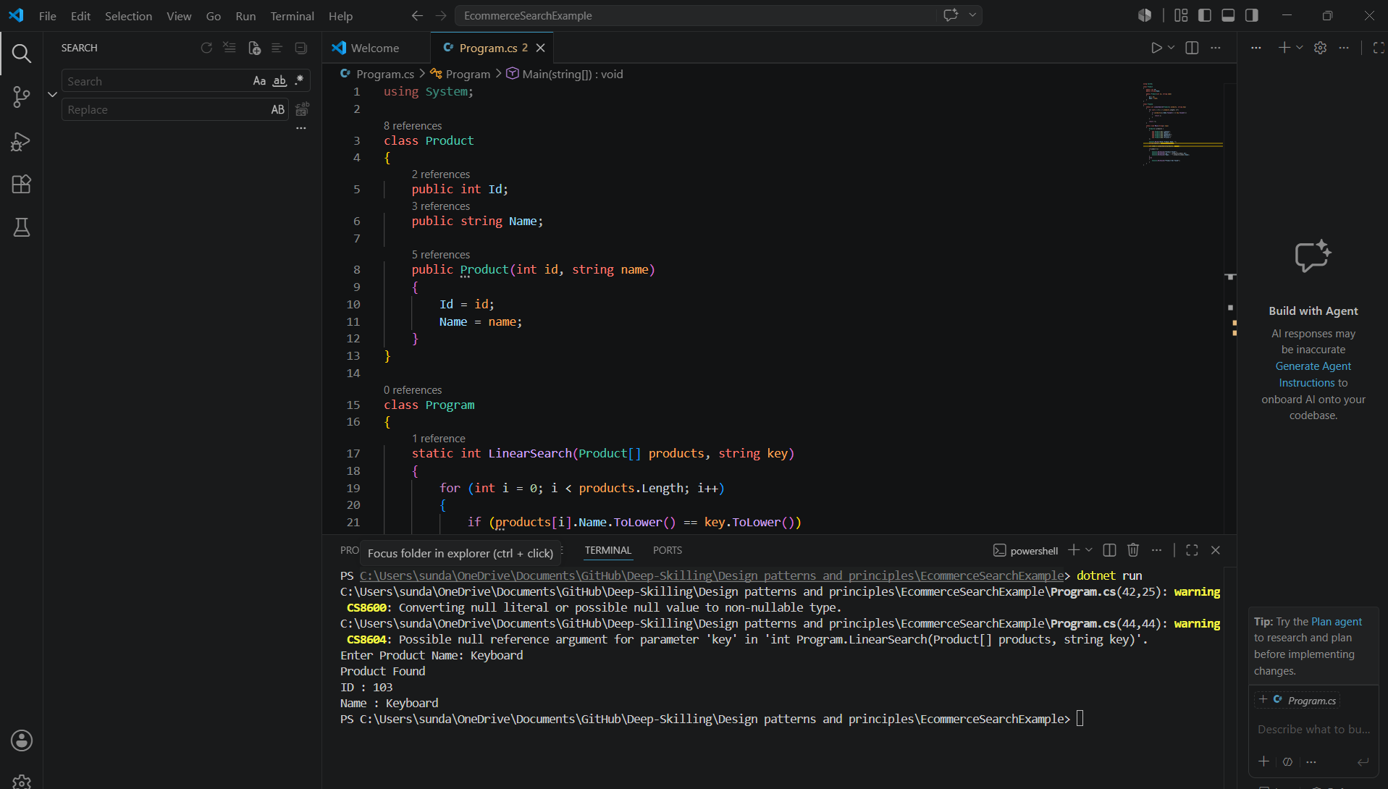
Exercise 7: Financial Forecasting
using System;
class Program
{
static double Forecast(double amount, double rate, int years)
{
if (years == 0)
{
return amount;
}
return Forecast(amount * (1 + rate), rate, years - 1);
}
static void Main(string[] args)
{
Console.Write("Enter Initial Amount: ");
double amount = Convert.ToDouble(Console.ReadLine());
Console.Write("Enter Growth Rate (Example 0.10): ");
double rate = Convert.ToDouble(Console.ReadLine());
Console.Write("Enter Number of Years: ");
int years = Convert.ToInt32(Console.ReadLine());
double futureValue = Forecast(amount, rate, years);

Console.WriteLine("Future Value = " + futureValue);
}
}
OUTPUT:
